OSPF Area Type and LSA Lab

Aaron Yu

Lab Partner: Jacob Chen and Aiden Yin

# Purpose

The purpose of this lab was to learn about and configure 3 different types of OSPF and find 6 types of LSAs. These area types are useful for larger scale networks that use OSPF because they allow for smaller routing tables for devices that do not need as much information about the whole topology, and the LSAs are important because they are used by OSPF to share information about the topology and create routes.

# Background Information

OSPF is a routing protocol used to automatically create routes throughout a network to find the shortest path between devices for a packet to travel. In a larger topology, using just multi-area OSPF will not be enough to reduce resource usage on devices, and since not all routers need to know external routes or even the other areas in the network, different types of stub areas can be implemented to reduce clutter of unneeded information and improve performance by blocking Link State Advertisements (LSA), which share information about the topology.

* Stub areas block
  + External routes distributed from the Autonomous System Boundary Router (ASBR), or the type-5 LSAs
  + The location of the ASBR, or type-4 LSAs
  + Receive all other OSPF information
* Totally stub areas build off stub areas but
  + Block type-3 LSAs, which means it only knows information about its area, but anything past the Area Boundary Router (ABR) is blocked
    - Because of this, a default route to the ABR is created so that if they need to forward information into other areas, it will go through there
* Not so stubby areas also build off stub areas but
  + An ASBR inside the NSSA will send a type-7 LSA instead of a type-5 LSA, which is the same as a type-5 but is used to go through the ABR
    - This LSA will convert into a type-5 when it passes the ABR

There are also type-1 and type-2 LSAs, which respectively are used to give information on directly connected routes and give information on the routers directly connected to the area’s Designated Router (DR), which is the router that tries to establish adjacencies with all the other routers in an area. These two packets are flooded in the whole OSPF area they started in, but do not go past the ABR. Type-6 LSA are for Multicast OSPF, which supports multicast routing through an OSPF process, but are deprecated and are not supported by Cisco. Type-8-11 LSAs are used in OSPFv3 but are not present in OSPFv2.

# Lab Summary

We started by researching the different types of OSPF areas and LSA types. This took most of the lab, as setting things up would not take long. We then tested the waters with Packet Tracer and the physical rack to solidify our understanding on how to generate these packets and how to log them. After, we created our final topology in Packet Tracer that had the 4 area types and could generate all the LSA types. We then connected and configured the routers following our topology and logged packets through Wireshark.

## Lab Commands

area # stub (no-summary)/nssa (default-information-originate): Configures the area type, and injects default route into routing protocol in an NSSA.

default-information originate: Injects default route into routing protocol.

redistribute: Inject routes into routing protocol based on arguments.

# Network Diagram

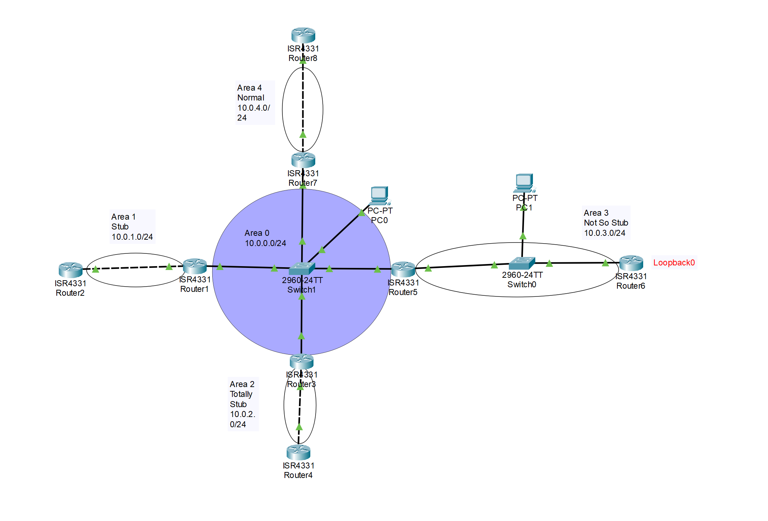

# Configurations

## Router 1

version 16.6.4

no service timestamps log datetime msec

no service timestamps debug datetime msec

no service password-encryption

hostname JacobAaronAidenR1

ip cef

no ipv6 cef

spanning-tree mode pvst

interface GigabitEthernet0/0/0

ip address 10.0.0.1 255.255.255.0

ip ospf 1 area 0

duplex auto

speed auto

interface GigabitEthernet0/0/1

ip address 10.0.1.1 255.255.255.0

ip ospf 1 area 1

duplex auto

speed auto

interface GigabitEthernet0/0/2

no ip address

duplex auto

speed auto

shutdown

interface Vlan1

no ip address

shutdown

router ospf 1

router-id 1.1.1.1

log-adjacency-changes

area 1 stub

ip classless

ip flow-export version 9

line con 0

line aux 0

line vty 0 4

login

end

## Router 2

version 16.6.4

no service timestamps log datetime msec

no service timestamps debug datetime msec

no service password-encryption

hostname JacobAaronAidenR2

ip cef

no ipv6 cef

spanning-tree mode pvst

interface GigabitEthernet0/0/0

no ip address

duplex auto

speed auto

shutdown

interface GigabitEthernet0/0/1

ip address 10.0.1.2 255.255.255.0

ip ospf 1 area 1

duplex auto

speed auto

interface GigabitEthernet0/0/2

no ip address

duplex auto

speed auto

shutdown

interface Vlan1

no ip address

shutdown

router ospf 1

router-id 2.2.2.2

log-adjacency-changes

area 1 stub

ip classless

ip flow-export version 9

line con 0

line aux 0

line vty 0 4

login

end

## Router 3

version 16.6.4

no service timestamps log datetime msec

no service timestamps debug datetime msec

no service password-encryption

hostname JacobAaronAidenR3

no ip cef

no ipv6 cef

spanning-tree mode pvst

interface GigabitEthernet0/0/0

ip address 10.0.0.2 255.255.255.0

ip ospf 1 area 0

duplex auto

speed auto

interface GigabitEthernet0/0/1

ip address 10.0.2.1 255.255.255.0

ip ospf 1 area 2

duplex auto

speed auto

interface GigabitEthernet0/0/2

no ip address

duplex auto

speed auto

shutdown

interface Vlan1

no ip address

shutdown

router ospf 1

router-id 3.3.3.3

log-adjacency-changes

area 2 stub no-summary

ip classless

ip flow-export version 9

line con 0

line aux 0

line vty 0 4

login

end

## Router 4

version 16.6.4

no service timestamps log datetime msec

no service timestamps debug datetime msec

no service password-encryption

hostname JacobAaronAidenR4

no ip cef

no ipv6 cef

spanning-tree mode pvst

interface GigabitEthernet0/0/0

no ip address

duplex auto

speed auto

shutdown

interface GigabitEthernet0/0/1

ip address 10.0.2.2 255.255.255.0

ip ospf 1 area 2

duplex auto

speed auto

interface GigabitEthernet0/0/2

no ip address

duplex auto

speed auto

shutdown

interface Vlan1

no ip address

shutdown

router ospf 1

router-id 4.4.4.4

log-adjacency-changes

area 2 stub no-summary

ip classless

ip flow-export version 9

line con 0

line aux 0

line vty 0 4

login

end

## Router 5

version 16.6.4

no service timestamps log datetime msec

no service timestamps debug datetime msec

no service password-encryption

hostname JacobAaronAidenR5

no ip cef

no ipv6 cef

spanning-tree mode pvst

interface GigabitEthernet0/0/0

ip address 10.0.0.3 255.255.255.0

ip ospf 1 area 0

duplex auto

speed auto

interface GigabitEthernet0/0/1

ip address 10.0.3.1 255.255.255.0

ip ospf 1 area 3

duplex auto

speed auto

interface GigabitEthernet0/0/2

no ip address

duplex auto

speed auto

shutdown

interface Vlan1

no ip address

shutdown

router ospf 1

router-id 5.5.5.5

log-adjacency-changes

area 3 nssa

ip classless

ip flow-export version 9

line con 0

line aux 0

line vty 0 4

login

end

## Router 6

version 16.6.4

no service timestamps log datetime msec

no service timestamps debug datetime msec

no service password-encryption

hostname JacobAaronAidenR6

no ip cef

no ipv6 cef

spanning-tree mode pvst

interface Loopback0

ip address 23.23.23.23 255.0.0.0

interface GigabitEthernet0/0/0

no ip address

duplex auto

speed auto

shutdown

interface GigabitEthernet0/0/1

ip address 10.0.3.2 255.255.255.0

ip ospf 1 area 3

duplex auto

speed auto

interface GigabitEthernet0/0/2

no ip address

duplex auto

speed auto

shutdown

interface Vlan1

no ip address

shutdown

router ospf 1

router-id 6.6.6.6

log-adjacency-changes

ip classless

ip route 0.0.0.0 0.0.0.0 Loopback0

ip flow-export version 9

line con 0

line aux 0

line vty 0 4

login

end

## Router 7

version 16.6.4

no service timestamps log datetime msec

no service timestamps debug datetime msec

no service password-encryption

hostname JacobAaronAidenR7

no ip cef

no ipv6 cef

spanning-tree mode pvst

interface GigabitEthernet0/0/0

ip address 10.0.0.4 255.255.255.0

ip ospf 1 area 0

duplex auto

speed auto

interface GigabitEthernet0/0/1

ip address 10.0.4.1 255.255.255.0

ip ospf 1 area 4

duplex auto

speed auto

interface GigabitEthernet0/0/2

no ip address

duplex auto

speed auto

shutdown

interface Vlan1

no ip address

shutdown

router ospf 1

router-id 7.7.7.7

log-adjacency-changes

ip classless

ip flow-export version 9

line con 0

line aux 0

line vty 0 4

login

end

## Router 8

version 16.6.4

no service timestamps log datetime msec

no service timestamps debug datetime msec

no service password-encryption

hostname JacobAaronAidenR8

no ip cef

no ipv6 cef

spanning-tree mode pvst

interface Loopback0

ip address 34.34.34.34 255.0.0.0

interface GigabitEthernet0/0/0

no ip address

duplex auto

speed auto

shutdown

interface GigabitEthernet0/0/1

ip address 10.0.4.2 255.255.255.0

ip ospf 1 area 4

duplex auto

speed auto

interface GigabitEthernet0/0/2

no ip address

duplex auto

speed auto

shutdown

interface Vlan1

no ip address

shutdown

router ospf 1

router-id 8.8.8.8

log-adjacency-changes

default-information originate

ip classless

ip route 0.0.0.0 0.0.0.0 Loopback0

ip flow-export version 9

line con 0

line aux 0

line vty 0 4

login

end

# Conclusion

In this lab we learned about and configured different types of OSPF areas that block different LSAs to increase performance when routing. We spent most of the lab doing research to figure out what these areas and LSAs did, then we configured a topology that used these types and enabled us to log the LSAs that were generated from the OSPF process.

